REGISTRATION QR CODE

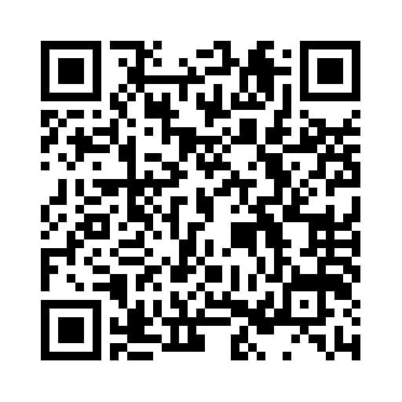

REGISTRATION LINK
https://docs.google.com/forms/d/e/1FAIpQLSciH1DX3HrmPD_fByV9V3sEW7qK9fTAjMG68zdjHrCIPRvHAw/viewform

